futures UPFRONT

Workbook 3.3
Person Centred Practice Across Cultures

Cross-cultural
story-based marketing –

1 story @ a time

July 2016

This workbook has been developed for National Disability Services by:
Barbel Winter, Managing Director, futures Upfront
and Maria Katrivesis, Consultant and Trainer

First published (July 2016)
© futures Upfront

For more information and for permission to reproduce please contact:
futures Upfront
email: info@futuresupfront.com.au
web: www.futuresupfront.com.au

Produced by
NDS NSW
Level 18, 1 Castlereagh St
Sydney, NSW 2000

Funded by
NSW Department of Family and Community Services.
© This publication is copyright

All rights reserved. Except as provided in the Copyright Act 1968 (Commonwealth), no use of this work, which is within the exclusive right of the copyright owners, may be made.

Contact
NDS
02 9256 3100
ndsnsw@nds.org.au
www.nds.org.au

About National Disability Services
National Disability Services is the peak body for non-government disability services. Its purpose is to promote quality service provision and life opportunities for people with disability. NDS’s Australia-wide membership includes more than 1000 non-government organisations, which support people with all forms of disability. NDS provides information and networking opportunities to its members and policy advice to state, territory and federal governments.

Table of Contents

1. Preface 2
1.1 How to use this workbook 3
1.2 What is this workbook about 3
1.3 Outcomes 3
1.4 Who is this workbook for 3
1.5 How long will it take to complete 3
2. The Workbook 4
2.1 Story-based marketing 4
2.2. What makes a good story? 5
2.3 Telling stories cross-culturally 10
3. Conclusion 13

Preface

This workbook is part of a series of resources for the disability services sector designed by futures Upfront for NDS with funding provided by the NSW Department of Family and Community Services; Ageing, Disability and Home Care.
The workbooks in this series are:
1. Individual Practices – working with people from CALD backgrounds with disability
1.1 Empathy – a practice to connect across cultures
1.2 Active listening – unconditional positive regard across cultures
1.3 Choice making – cross-cultural differences and what can we learn from them
1.4 Reflective Practice – why different points of view matter
1.5 Working effectively with interpreters
2. Organisational Practices – building a culturally responsive organisation
2.1 Terminology and data – a guide to understanding cultural diversity and disability
2.2 Making the business case – why diversity is good for business
2.3 A culturally responsive person centred organisation – key elements
2.4 Leading towards cultural responsiveness – a practical guide for managers, team leaders and coaches
2.5 Building a diverse workforce – practical strategies
2.6 Valuing bilingual workers – strategies to recruit, train and retain
3. Community Engagement – working alongside diverse communities
3.1 1 Community @ a time – culturally responsive community engagement principles and elements
3.2 Making Links – networking with CALD Communities
3.3 Cross-cultural story-based marketing – 1 story @a time
This workbook is part of ‘Community Engagement – working alongside diverse communities’.

How to use this workbook?
This workbook can be used in many different ways, including:
As a self-paced learning program by an individual
As a self- paced learning program for a group
As part of formal training organised by an organisation
As part of coaching and mentoring
This workbook includes exercises and opportunities for reflections (when working by yourself) or discussions (when working with others).
There is plenty of room in your workbook to take notes and make comments.

What is this workbook about?
This workbook builds on the idea of story-based marketing as a powerful person centred tool for communicating messages and marketing to individuals. Based on the common elements of story telling across cultures, it gives you a framework and some ideas to make your marketing much more relevant and attractive to culturally diverse audiences.

Outcomes
By the end of the workbook you will be able to:
Understand story based marketing
Identify some common elements of good storytelling
Telling stories cross-culturally.

Who is this workbook for?
People in an organisation interested in marketing their organisation to culturally diverse communities
People in an organisation charged with writing marketing and promotion materials
Anyone in an organisation wanting to promote their organisation to people from diverse communities.

How long will it take to complete?
This workbook should take about 30-45 minutes to work through, longer if you watch all the videos

The Workbook
The main part of this workbook is divided into the following sections:
Story-based marketing
What makes a good story?
Telling stories cross-culturally

Story-based marketing
In the disability sector like all other human services, we have seen an increase in marketing of services, partly in preparation for individualised funding in a more competitive marketplace open to the choice of customers.
Story-based marketing is the idea that an organisation can engage with its (potential) customers through the power of stories. Truthful stories of your work not only engender trust, but also powerfully demonstrate the value of your work. Effective story-based marketing is not simply telling people what you do and how you do it, but also showing them.
In the not-for-profit, for-purpose sector, many of the stories that are told are about people who benefit from our services.
Video

Have a look at this story: http://www.benevolent.org.au/about/our--story

The Benevolent Society is the oldest not-for-profit in Australia, they tell us:

Our story is Australia’s story.
“Imagine an Australia without free legal aid, where child labour is still widespread, where there is no old age pension and no specialist maternity care. You’ve just imagined an Australia without The Benevolent Society.
Our story is the story of the nurses, the social workers and the carers who supported people in times of need. It’s the story of the thousands of people who donated time and money to help us help others and the advocates who fought for so many things we take for granted today.
Right from the start, we’ve been there for anyone who needs us, at the heart of change”.
The story by the Benevolent Society is a story based on its history. It powerfully tells the story of the work of the Benevolent Society. The images of people (who you will notice do not have a voice) are used here to personalise and to link the work of the Benevolent Society to those who have benefited from the work.
Video
Think about some of the NDIS videos and stories you might have seen, for example: http://www.ndis.gov.au/people-disability/videos-and-stories

All of these stories are focused on the individual and are told to illustrate the work of the NDIS. And certainly because it is all about the individual this format works.
A quick glance over a dozen or so websites will show that many disability services organisations now market themselves through stories.
Workbook Exercise
Have a look at some disability services websites. What are some of the different kinds of stories you can find? Why do they work/don’t work for you?

What makes a good story?
The following infographic is a great description of what makes a good story.

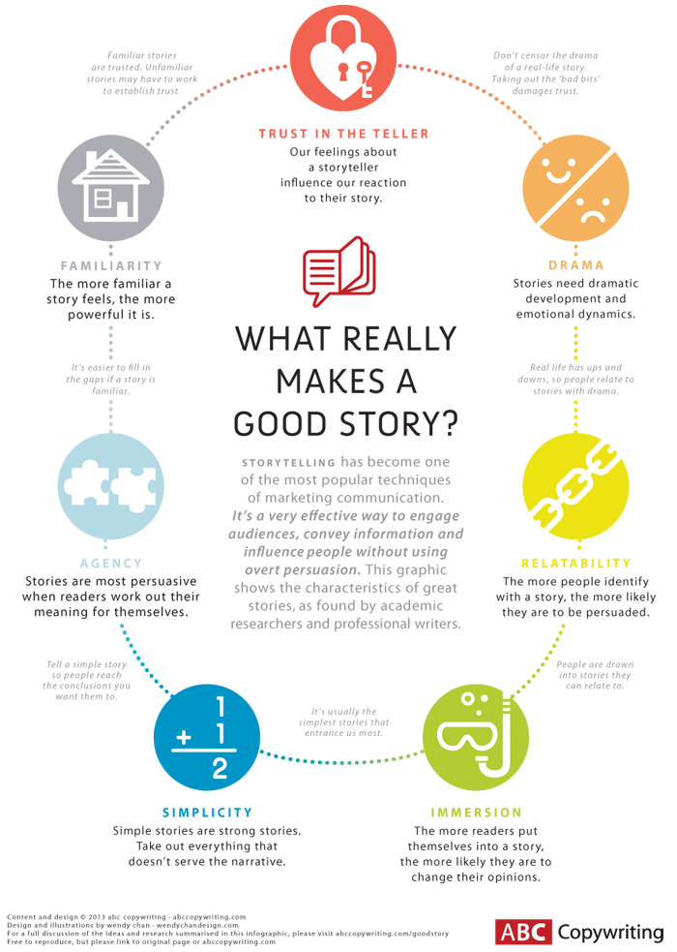
Looking at the infographic on the previous page, here are some of the
Looking at the above infographic, some questions you might like to ask yourself when reading, listening to, or watching a story are:
Do you trust the storyteller?
Is there drama?
Can you put yourself into the story?
Is it simple but strong?
Did you work out the meaning yourself?
Did the story seem familiar?

How I overcame episodic disability challenges and returned to full time work
By Dan O’Reilly, 27 April 2016
(Please note that all references to the organisation have been removed, but the name of the author remains)
“Eighteen months ago, when I first started using xxx Employment Service, I wasn’t ready to start work because I have epilepsy and fractured six vertebrae during two seizures.
The staff that supported me at xxx understood that I needed rehabilitation and assistance to re-enter the workforce. They worked as a team and helped me with things like writing a cover letter, building my resume and practicing my interview skills.
Finally, after a lot of preparation and rehab, I was finally ready to have a go at returning to work.
I started applying for jobs and soon after the search began, xxx staff told me about a new job opportunity that had come up within xxx. I looked at the position description and went through the application process just like any other candidate.
After going through the interview stage and being shortlisted, I was stoked to hear that I was selected for the position of Customer Contact Advisor.
In this role I get to chat with xxx’s current and potentially future customers about any enquiries they have. I’m also able to help them get informed about the National Disability Insurance Scheme (NDIS), chat about their goals and discuss what they hope to achieve by using our services.
I’ve learnt so much already and am enjoying my new role. My manager Katie is an excellent teacher and I am loving being back at work. I feel like I’m part of something now, as opposed to being very much removed from society for an expanded period of time.
My seizures are now well managed and controlled with the right medication so I don’t see my epilepsy as an issue affecting my job in a major way.
The NDIS is a big change and some people are understandably nervous about it. I’m looking forward to hopefully being able to make things a bit easier for people who contact us and seeing how the services xxx offers can work with people on achieving their goals.”

Workbook Exercise

Can you identify the different story telling elements in Dan’s story?

Another way of understanding stories is to look at the big stories of different cultures. Joseph Campbell, an American scholar who studied myths and stories across cultures, did just that. One of his most famous books: The Hero with a Thousand Faces describes the hero’s journey or monomyth as a common theme used by many cultures to tell stories.
A Monomyth basically goes like this: an (often initially reluctant) hero goes on an adventure, experiences crisis and comes home transformed.
Think about Buddha meditating under the Bodhi tree. Think the Isra and Mi’raj, the night journey of Mohammad. Think Jesus in the desert for 40 days. Think Homer, Gilgamesh and Harry Potter. Think Dorothy in the ‘Wizard of Oz’, Simba in the ‘Lion King’, Katniss in the “The Hunger Games’. And of course Luke Skywalker in ‘Star Wars’. They are all monomyths.
Video
For a great example of using monomyths to advertise, have a look at this advertisement by apple https://www.youtube.com/watch?v=nmwXdGm89Tk

Think different
"Here's to the crazy ones. The misfits. The rebels. The troublemakers. The round pegs in the square holes; the ones who see things differently. They're not fond of rules, and they have no respect for the status quo. You can quote them, disagree with them, glorify and vilify them. About the only thing you can't do is ignore the. Because they change things. They push the human race forward. And while some may see them as crazy, we see genius. Because the people who are crazy enough to think they can change the world are the ones who do."
Many of the stories of large companies and their success are told through the ‘journey’ of their leaders: Steve Jobs and Apple, Richard Branson and Virgin, Anita Roddick and the Body Shop.
Workbook Exercise
Thinking about Dan’s story “How I overcame episodic disability challenges and returned to full time work” above. What do you think are the commonalities between the story written by Dan and the Hero’s Journey/ monomyths? Do you think these kind of stories work and if so, why?

Telling stories cross-culturally
Using the infographic above and the idea of the monomyth, it might now be easy enough to pull out the key elements that make a story work cross culturally:
Trust in the storyteller: What is your credibility in diverse communities or even with a particular community? Do you have any standing? What does the community know about your organisation? If you have little standing, building awareness and trust about your organisation might be one of the reasons to start telling stories cross-culturally.
Drama: Thinking about the structure of the monomyth, the Hero’s journey. What elements are there in your story that build on the idea of the often reluctant response to a calling, a journey of transformation and a heroic return? Critical here is that a dramatic story needs to have some ups and downs, but please be aware of what Stella Young and others have called ‘inspiration porn’ when it comes to telling stories about people with disability.
Relatability: Can the audience relate to the story you are telling? Can people identify with the story? In this context, it might be important to point out that people from a particular cultural group might not need to see themselves or their specific community in the story in order to identify with it. But what people might need to see is that a diverse range people are included.
Immersion: If people can put themselves into a story it has more impact. Immersion is similar to relatability. When people can relate to a story they can more easily immerse themselves in it. Immersion is easier if the story describes environments that are familiar to us; just like two moons and purple soil tells us that we are on an alien planet. Think about what you can build into a story to make it more familiar and, therefore, easier to relate to. Cultural signifiers, description of foods or rituals? One of the more popular methods we see in stories told by organisations about people with disability is to use names that clearly indicate that someone is likely to be from a CALD background, but often that is all they do.
Familiarity: Again, similarly to the two elements above, if a story feels familiar it has more impact.

Finding stories written by disability organisations that are explicitly targeting a cross-cultural audience seems almost impossible. Looking at other areas, here is a story told by a South Indian woman for the Pink Sari Project, a group aiming to raise awareness about breast screening among Indian and Sri Lankan communities, as those communities have one of the lowest breast screening rates.
Gladys Roach
“In 1965, I moved to Adelaide with my husband Neville from Mangalore, South India. With an eagerness to fit in with the locals, I went door-to-door selling Avon wearing a western frock. The neighbours just peeped through their curtains, but they never answered me.
I was disheartened, and I was all set to give up on the new career when my friend suggested ditching the western frock and putting on my sari instead. I was a bit apprehensive, but I decided to give it a go. Decked out in a beautiful sari, I returned to those familiar doors, and much to my surprise, they welcomed me, and even offered tea and biscuits!
Ever since I learned that my sari created intrigue amongst people and became a conversation starter.
Imagine my shock when I learned I have a tumour in my breast, There I was, wanting to live a normal life like most people, and all of a sudden, the dreadful news! It was so deep that they only detected it when I went for a mammogram.
With early detection, I only needed to have radiotherapy. Thankfully, I am cancer-free today. I can still relate to the trauma and tragedy related to breast cancer first hand after losing my daughter to the disease recently.
I went through a difficult time with my treatment and the only thing that sustained me throughout the ordeal was my family.
Now, it is my mission to encourage every woman to make sure they get tested regularly and to be in tune with their bodies. This is why I have decided to share my story and support the Pink Sari Project.”

Workbook Exercise
In Gladys Roach’s story above can you identify what works in terms of relatability, immersion, drama and familiarity? Do you think the story works and do you think it speaks to the target audience (women from Southern India and Sri Lanka) and achieve its purpose?

Conclusion
This workbook aimed to assist you in understanding how to tell cross-cultural stories of your organisation to connect with and market to cross-cultural audiences.
You may also want to have a look at the other two workbooks in the series on “Community Engagement – working alongside diverse communities” to learn more about engaging with diverse communities.

Reflections
What are some of the take away messages from this workbook? Are there things you disagree with? Was there something that surprised you?

Benevolent Society; http://www.benevolent.org.au/about/our--story#sthash.jg3wzj0L.dpuf
Campbell, J. (1949) The Hero with a thousand faces
Apple advertising: Think Different; https://www.youtube.com/watch?v=nmwXdGm89Tk
Young Stella: I’m not your inspiration, thank you very much https://www.youtube.com/watch?v=8K9Gg164Bsw ; Cara Liebowitz: Explaining inspiration porn to non-disabled people http://thebodyisnotanapology.com/magazine/explaining-inspiration-porn-to-non-disabled-people/
Portraits in Pink, http://pinksariproject.org/Support_us.aspx?ID=6

