futures UPFRONT

Workbook 3.1

Person Centred Practice Across Cultures

1 Community @ a time –

culturally responsive community engagement principles and elements

July 2016

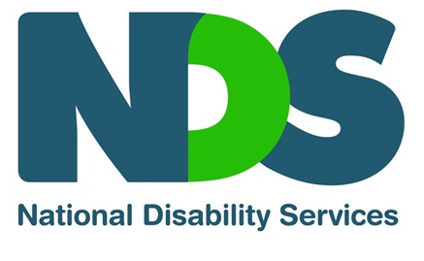

This workbook has been developed for National Disability Services by:
Barbel Winter, Managing Director, futures Upfront
and Maria Katrivesis, Consultant and Trainer

First published (July 2016)
© futures Upfront

For more information and for permission to reproduce please contact:
futures Upfront
email: info@futuresupfront.com.au
web: www.futuresupfront.com.au

Produced by
NDS NSW
Level 18, 1 Castlereagh St
Sydney, NSW 2000

Funded by
NSW Department of Family and Community Services.
© This publication is copyright

All rights reserved. Except as provided in the Copyright Act 1968 (Commonwealth), no use of this work, which is within the exclusive right of the copyright owners, may be made.

Contact
NDS
02 9256 3100
ndsnsw@nds.org.au
www.nds.org.au

About National Disability Services
National Disability Services is the peak body for non-government disability services. Its purpose is to promote quality service provision and life opportunities for people with disability. NDS’s Australia-wide membership includes more than 1000 non-government organisations, which support people with all forms of disability. NDS provides information and networking opportunities to its members and policy advice to state, territory and federal governments.

Table of Contents

1. Preface 2
1.1 How to use this workbook? 2
1.2 What is this workbook about? 3
1.3 Outcomes 3
1.4 Who is this workbook for? 3
1.5 How long will it take to complete? 3
2. The Workbook 4
2.1 Introduction 4
2.2 What is Community Engagement? 4
2.2.1 Some definitions 4
2.2.2 The Community Engagement Continuum 5
2.3 Community engagement across cultures 7
2.4 Community Engagement Principles 9
2.4.1 Human Rights framework 9
2.4.2 Strength based approaches to build social capital 10
2.4.3 Clarity of purpose 10
2.5 Key elements for culturally responsive community engagement 11
2.5.1 Building trust 11
2.5.2 Finding shared meaning 12
2.5.3 Support Self Determination 13
2.5.4 Making Links 13
3. Conclusion 15

1. Preface
This workbook is part of a series of resources for the disability services sector designed by futures Upfront for NDS with funding provided by the NSW Department of Family and Community Services; Ageing, Disability and Home Care.
The workbooks in this series are:
1. Individual Practices – working with people from CALD backgrounds with disability
1.1 Empathy – a practice to connect across cultures
1.2 Active listening – unconditional positive regard across cultures
1.3 Choice making – cross-cultural differences and what can we learn from them
1.4 Reflective Practice – why different points of view matter
1.5 Working effectively with interpreters
2. Organisational Practices – building a culturally responsive organisation
2.1 Terminology and data – a guide to understanding cultural diversity and disability
2.2 Making the business case – why diversity is good for business
2.3 A culturally responsive person centred organisation – key elements
2.4 Leading towards cultural responsiveness – a practical guide for managers, team leaders and coaches
2.5 Building a diverse workforce – practical strategies
2.6 Valuing bilingual workers – strategies to recruit, train and retain
3. Community Engagement – working alongside diverse communities
3.1 1 Community @ a time – culturally responsive community engagement principles and elements
3.2 Making Links – networking with CALD Communities
3.3 Cross-cultural story-based marketing – 1 story @a time
This workbook is part of ‘Community Engagement- working alongside diverse communities’.

How to use this workbook?
This workbook can be used in many different ways, including:
As a self-paced learning program by an individual
As a self-paced learning program for a group
As part of formal training organised by an organisation
As part of coaching and mentoring.
This workbook includes exercises and opportunities for reflections (when working by yourself) or discussions (when working with others).
There is plenty of room in your workbook to take notes and make comments.

What is this workbook about?
This workbook is helping you understand the key principles and elements of engaging with CALD communities
We recommend you use this as the foundation for Workbook 3.2 Making Links.

Outcomes
At the end of the workbook you will:
Be able to think more deeply about engaging with CALD communities
Apply some key principles to your CALD community engagement strategies
Identify a range of key culturally responsive community engagement elements.

Who is this workbook for?
People interested in engaging with CALD communities
People who want to deepen their understanding of how to respectfully and meaningfully connect with different communities.

How long will it take to complete?
This workbook should take about 45 minutes to work through.

The Workbook

Introduction
This workbook focuses on some of the key principles and elements when working with one of the 200 or so different ethnic communities in Australia. We strongly recommend that you read this workbook before moving on to “Workbook 3.2 Making Links”, the next workbook in this series.
While this workbook focuses specifically on working with ethnic communities, the principles and elements can also be applied to working with any community.

Reflections
Do you belong to a community (local, faith based, interest based, ethnicity based or language based) or formalised community group (Local Resident Action group, a Landcare group, a choir, a faith based community, a painters group, an interest based facebook group)? Can you list some of the communities you belong to?

What is Community Engagement?

Some definitions
“Community engagement is a planned process with the specific purpose of working with identified groups of people, whether they are connected by geographic location, special interest, or affiliation or identify to address issues affecting their well-being”
Other definitions refer to community engagement as, specifically, the engagement of governments with their citizens.
The definition we want to work with, however, specifically talks about the collaborative nature of the engagement with the community:
“Community Engagement is the process of working collaboratively with and through groups of people affiliated by geographic proximity, special interest, or similar situations to address issues affecting the well-being of those people”
We are interested here in focusing particularly on collaborative community engagement practices with and through groups of people that affiliate on the bases of ethnicity and/or language.

The Community Engagement Continuum

The following continuum is based on the Public Participation Spectrum developed by the International Assoc. for Public Participation and shows the effectiveness of collaboration as community engagement strategy in achieving connections, higher levels of trust and ultimately more impact than some other strategies.

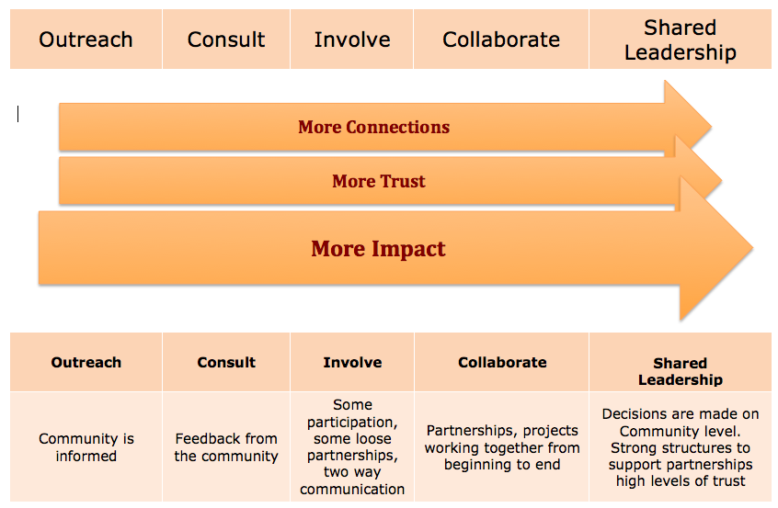
This continuum clearly highlights that different engagement strategies achieve similar outcomes but different levels of intensity.
Below we argue that irrespective of which one of the strategies you employ to engage with a community, your engagement must be based on clear principles and contain some key elements.

Reflections
Thinking about the communities and community groups you listed above, have other organisations or maybe your council ever tried to connect with your community? Thinking about those engagements, where on the continuum above would you place those engagements and why? If you never had such an experience, can you have a think about which kind of engagement you prefer (maybe a different times/ situations) and why?

Community engagement across cultures

Reflections
Please think about two of the communities/groups you belong to that you identified above. Maybe think about two very different ones. Maybe one is not structured at all and one is very structured; maybe one is focused on a task or specific purpose and one exists because of external reasons (for example, the street you live in). What are the different words you would use to describe the different communities? How are they different? Do they have different ways of organising, doing things, communicating with each other, etc.?

From your examples above and from our experiences, we know that no two communities are the same. In addition, communities are also not homogeneous within themselves as they are made of individuals with diverse values, histories and different ways of seeing the world.
Given that this is a series of workbooks on person centred practice across cultures, the following definition of culture might be useful:
Culture is “a complex integrated system of thought and behaviour shared by members of a group – a system whose whole pattern allows us to understand the meanings that people attach to specific facts and observations”
To collaborate and to build relationships that are meaningful and impactful for the benefit of all, we need to learn and understand about the meanings a community attaches to certain things..
The title of this workbook ‘1 community @ a time’ refers to the idea of person centred approaches, based on our understanding that each person is an individual and that their disability, as well as their ethnicity, forms part but not all of who they are. Similarly when engaging with a community, we are always working with a group made up of individuals, who come with their own values, meanings, histories and experiences of ethnicity and language that continually shape and re-shape that community.

Reflections
Have another look at your reflections above in 2.3. Can you think a bit more about the different words you used? The different ways that those communities communicate or organise? For example, can you think a bit more about when someone says it will start at 8 pm, does that mean the same in both groups? When the task is to bring a plate, are there similar expectations? Are you more relaxed in one of the communities and more formal in the other? Do you dress differently?

All of those things you listed above are what makes the culture of a community.
Think about the culture of Toastmasters, an international organisation which operates locally. It is run by local people, people come from all walks of life and yet all follow the same rules. Think about any sport. It’s played locally but the rules of the game might be the same around the world. These are examples of communities that in some ways are highly regulated.
Compare that with a group of people that want to work together to make their local community more inclusive; or a group of people who have in common that they were all born in the same country. Those groups are mostly not externally regulated and people, while sharing a purpose or reason for the group, have to work out how to be together and organise themselves as a community.
These latter communities are more likely the kinds of communities you will be engaging with in your work with people from CALD backgrounds with disability. In the absence of external rules and structures that you can learn about prior to engaging, you will need to build your community engagement on some principles that can assist and guide you.

Community Engagement Principles
Community engagement – 1 community @ a time is not about following a prescriptive set of tools and processes, but builds on your learning and understanding, your empathy and your ability to work alongside people. In the absence of such prescriptive processes principles, or fundamental values, are critical in guiding our engagement.
The following three principles are critical as a basis for your culturally responsive community engagement initiatives:

Human rights framework
The international human rights framework with its mechanisms and treaties provides an important framework that can assist us in our engagement with communities. All our engagements must enhance, not diminish, the human rights of all the people we engage with.
Critical in our context is that a perception of differences of human rights must not be traded against each other. For example, the UN Convention on the Rights of Persons with Disabilities is of equal standing to the International Convention on the Protection of all Migrant workers and members of their families. Both conventions have equal standing to the UN Convention on the Rights of the Child.
Also important in our work with communities is that when there are tensions between the different human rights treaties and conventions, we work alongside communities to either resolve those differences or acknowledge the tensions and then work so that all members of a community have their human rights. In our work with any community we must uphold that human rights are not culturally relative, but that they are universal.

Strength based approaches to build social capital
Similarly to our work with individuals, we start our work with communities from a focus on the gifts and the possibilities each community brings rather than focusing on the problems and deficits. The aim of our work with communities must be that we bring together the knowledge and skills within a community to collaborate together to create better outcomes and achieve whatever the community is aiming for. As we do in our work with individuals, we move from problem to possibility.
We work with the connectedness within a community to build more social capital. Social capital is a term much used in disability and community services sectors. If you are thinking inclusion for people with disability, social capital, not individualised funding packages, is what will make communities welcoming.

Clarity of purpose
One of the most important principles we would urge you to think through before engaging with any community is to get clear on your purpose and articulate this purpose to the community you are collaborating with.
If you want to provide information with the purpose of promoting your services to a community, do not pretend you want to work in partnership with a community to achieve a goal they have identified. If you want to lead the engagement, if you want more customers from this community; whatever your purpose, be clear about it.

Reflections
Do you have a community in mind that your organisation wants to engage with? Why do you want to engage with this community? What is your purpose? Right from the beginning can you think about the strengths of the community and list them here? Finally, what do you think are the key human rights issues for the community and what does that mean for your work with the community?

Key elements for culturally responsive community engagement
Finally, three key community engagement elements that are useful when collaborating with CALD communities:

Building trust
The importance of trust as a critical element in engaging with communities cannot be overestimated. Trust is the glue that holds communities together and if we, and our organisation, want to meaningfully engage with a community, we need to understand how to build trust, often in the face of disappointment. Many communities have been failed over and over again; by outsiders, by experts, by people who promised and failed to deliver quick solutions and easy fixes to the issues and concerns of the community.
Below is a list of what works when it comes to building trust:
We are accountable – “Accountability precedes the development of trust” – Before anything else comes accountability. Being answerable to the community for what we said, what we do and who we are. Being one’s word and having integrity of word and action are critical components of this. We do what we said we would and we report back to the community.
We are open – We are (actively) listening to others and we are sharing ourselves and our learning as a contribution to others. We share information, knowledge, networks and resources freely.
We share successes (as well as failures)
We don’t have any hidden agenda – we are honest and clear about our purpose.
We take time – we understand that it takes the time it takes. We do not have an agenda about when things need to be done by. We know it takes time to build trust and we know every community is different.
We show respect – through our words and our actions. Our respect can be measured in how we relate to all members of the community, from the most powerful member to the least powerful member in the community.
We learn what trust looks like – We work with the community to understand what trust looks like for the community. We ask questions about experiences of trust as well as experiences when trust was betrayed. We learn from the community about what behaviours and attributes are seen as demonstrating trust and we show those in our dealings with people.

Finding shared meaning
Above we identified that
Culture is “a complex integrated system of thought and behaviour shared by members of a group – a system whose whole pattern allows us to understand the meanings that people attach to specific facts and observations”
We learn to understand how culture shapes the meanings of how the community understands itself, such as
- how individuals and groups relate to each other;
- how power and resistance are determined;
- how partnerships, trust and reciprocity are enacted and negotiated;
- how disability, help- seeking and rights are understood;
Then our understanding and practice of community engagement with a particular community ought to change in line with those meanings.
‘Shared meaning making’ is a theory and a strategy that assists us to recognise that
“people have different personalities, upbringings, cultures and experiences, which influence they way we interpret and understand messages.”
Focusing on the meanings that a group of individuals share, rather than some predetermined stereotypical assumptions we make about a community, will lead not only to a much richer and more accurate understanding of the individuals and the community, but also
“help reveal how community conditions are determined by social economic and political forces that simply by individual choices.”
Shared meaning making as a strategy emerges because perceptions, or new ways of perceiving the world, our environment, the meaning of an idea or a concept overlap. The strategy is thus striving to understand each others point of views and looking for the overlap in our perceptions. (Please note that shared meaning making is also one of the core elements underpinning Workbook 3.3 Cross-cultural story-based marketing)

Support Self Determination
“All people have the right to self determination. By virtue of that right they freely determine their political status and freely pursue their economic, social and cultural development”
In terms of our strategies for engaging with communities this means that we take the lead from the people we work with and we use our knowledge, skills and connections to further the purpose identified by the community.
We then become allies in the journey towards self-determination, not leaders but followers. We acknowledge that while we might have skill, knowledge and connections that are useful and helpful to the self-determination of the community, we are not the experts. We, like the community we are collaborating with, have gifts; we can create possibilities; we can ask questions, which are often much more useful than (simplistic) answers. If answers come they emerge from within the community and are based on the insights, strengths and meaning shared by the community. Sometimes those new, shared meanings may, at least in part, have evolved from the engagement with you and your organisation.

Making Links
Finally, our last strategy is to encourage you to now move on to the next workbook in this series. Workbook 3.2 Making Links, gives you loads of practical, hands-on strategies including:
Who do we know?
What are our current networking practices?
Identifying and targeting CALD community?

Conclusion
This workbook aimed to assist you in understanding some of the key principles and underlying elements of engaging with communities.
This workbook lays the theoretical and values foundations for the more , hands-on, practice-based Workbook 3.2 Making Links of the same series.
Reflections
What are some of the take away messages from this workbook? Are there things you disagree with? Was there something that surprised you?

Queensland Department of Emergency Services (2001) Charter for community engagement, Community Engagement Unit, Strategic and Executive Services, Queensland Department of Emergency Services
Cavaye, Dr. J (2001) 'Community engagement framework project: scoping and review paper', Cavaye Community Development/CEO Committee on Land Resources, Queensland, citing OECD (2001) 'Engaging Citizens in policy-making: information, consultation and public participation', PUMA Policy brief No 10, July 2001, Organisation for Economic Co-operation and Development
National Institute of Health (US) (2011): Principles of Community Engagement
www.iap2.org.au
Kiefer, C. (2007): Doing Health Anthropology
Knack, S., & Zak, P. (2005). Building trust: Public policy, interpersonal trust, and economic development. Supreme Court Economic Review
Kiefer, C. (2007): Doing Health Anthropology
Barnett & O’Rourke (2011): Communication: Organisation and Innovation
National Institute of Health (US) (2011): Principles of Community Engagement
Please note that those and related concepts are discussed in greater detail in the Empathy and Reflective Practice workbooks in this series.
International Covenant on Civil and Political Rights (ICCPR), Article 1

