futures UPFRONT

Workbook 2.4
Person Centred Practice Across Cultures

Leading towards cultural responsiveness -

a practical guide for managers, team leaders and coaches

July 2016

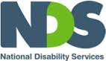
This workbook has been developed for National Disability Services by:
Barbel Winter, Managing Director, futures Upfront
and Maria Katrivesis, Consultant and Trainer

First published (July 2016)
© futures Upfront

For more information and for permission to reproduce please contact:
futures Upfront
email: info@futuresupfront.com.au
web: www.futuresupfront.com.au

Produced by
NDS NSW
Level 18, 1 Castlereagh St
Sydney, NSW 2000

Funded by
NSW Department of Family and Community Services.
© This publication is copyright

All rights reserved. Except as provided in the Copyright Act 1968 (Commonwealth), no use of this work, which is within the exclusive right of the copyright owners, may be made.

Contact
NDS
02 9256 3100
ndsnsw@nds.org.au
www.nds.org.au

About National Disability Services
National Disability Services is the peak body for non-government disability services. Its purpose is to promote quality service provision and life opportunities for people with disability. NDS’s Australia-wide membership includes more than 1000 non-government organisations, which support people with all forms of disability. NDS provides information and networking opportunities to its members and policy advice to state, territory and federal governments.

Table of Contents

1. Preface 2
1.1 How to use this workbook? 2
1.2 What is this workbook about? 3
1.3 Outcomes 3
1.4 Who is this workbook for? 3
1.5 How long will it take to complete? 3
2. The Workbook 4
2.1 Introduction 4
2.2 Why move from cultural awareness to cultural responsiveness? 5
2.2.1 What does cultural awareness mean? 5
2.2.2 What is cultural responsiveness? 6
2.2.3 My role as a team leader/ manager 7
2.3 How to move from cultural awareness to cultural responsiveness? 7
2.3.1 Understanding culture – beyond cultural stereotypes 7
2.3.2 Understanding my identity 9
3. Conclusion 13

Preface
This workbook is part of a series of resources for the disability services sector designed by futures Upfront for NDS with funding provided by the NSW Department of Family and Community Services; Ageing, Disability and Home Care.
1. Individual Practices – working with people from CALD backgrounds with disability
1.1 Empathy – a practice to connect across cultures
1.2 Active listening – unconditional positive regard across cultures
1.3 Choice making – cross-cultural differences and what can we learn from them
1.4 Reflective Practice – why different points of view matter
1.5 Working effectively with interpreters
2. Organisational Practices – building a culturally responsive organisation
2.1 Terminology and data – a guide to understanding cultural diversity and disability
2.2 Making the business case – why diversity is good for business
2.3 A culturally responsive person centred organisation – key elements
2.4 Leading towards cultural responsiveness – a practical guide for managers, team leaders and coaches
2.5 Building a diverse workforce – practical strategies
2.6 Valuing bilingual workers – strategies to recruit, train and retain
3. Community Engagement – working alongside diverse communities
3.1 1 Community @ a time – culturally responsive community engagement principles and elements
3.2 Making Links – networking with CALD Communities
3.3 Cross-cultural story-based marketing – 1 story @a time
This workbook is part of “Organisational Practices - building a culturally responsive organisation” series.

How to use this workbook?
This workbook can be used in many different ways, including:
As a self-paced learning program by an individual
As a self-paced learning program for a group
As part of formal training organised by an organisation
As part of coaching and mentoring.
This workbook includes exercises and opportunities for reflections (when working by yourself) or discussions (when working with others).
There is plenty of room in your workbook to take notes and make comments.

What is this workbook about?
This workbook is a practical guide designed for anyone who leads, supervises, coaches or mentors. The workbook takes you through from why to how you can guide your team member/s towards more cultural responsive person centred practices.
We recommend you also use some of the other workbooks in this series

Outcomes
At the end of the workbook you will:
Be able to understand why cultural responsiveness and not just cultural awareness is critical in providing person centred supports
Use three practical exercises with your team/staff to explore the idea of cultural responsiveness

Who is this workbook for?
Anyone leading, managing, coaching, mentoring or guiding others to become better in working alongside people with disability
People interested in improving their own culturally responsive person centred practice

How long will it take to complete?
This workbook should take about 30 minutes to read through. Doing the exercises fully either by yourself or with others will add significantly more time.

The Workbook

Introduction
We all want it easy some days. We all love an easy answer and we want no more than a few dot points to guide us to the solution. If you don’t believe us have a look at “The Universe: Big Bang to Now in 10 easy steps”. No matter how complex or difficult an issue, we want a nicely chunked down answer.
So it is no wonder that despite all of our efforts to think about the people we support as individuals, to focus on one person at a time and to really appreciate the saying “if you meet one person with a disability you have met … one person with a disability”, we struggle with this.
Because we want easy answers even though we know everyone is different, we want standardised knowledge and tools, stereotypes to guide us through working with people, especially if they are different from ourselves.
This workbook will give you some answers as to why, in working from a person centred perspective, we need to be culturally responsive not simply culturally aware. It will also provide you with some easy to implement exercises you can share with your team/staff to explore the limitations of cultural awareness and begin to see the opportunities of cultural responsive person centred practice.

Reflections
What do you do when your team members/staff ask for easy answers when it comes to working with people? For example, how do you respond when your staff asks you: “Tell me what I need to do to work with this person from Lebanese background?”

Why move from cultural awareness to cultural responsiveness?
In working with people with disability we are moving away from defining, and thus limiting, people by focusing only on their disability. We are moving towards thinking about people as individuals with different needs and wants. While clearly disability matters, it is far from the only thing that matters in a person’s life.
This is at the heart of person centred thinking and doing.
Yet, when it comes to working with people who are from a different ethnic background, we still want to understand cultural norms and use those to guide us in our dealings with people who are culturally different from us.
    - What does cultural awareness mean?
Traditionally cultural awareness training was delivered in similar ways to how we used to deliver disability awareness training. It was all about groups of people that shared a characteristic – their ethnic background in cultural awareness training and their disability type in disability awareness training. We were provided with checklists on how to ‘deal’ with people who had this characteristic.
Here are some examples:

Similarities between disability & cultural awareness training
Disability awareness training | Cultural awareness training
People with autism lack empathy | People from China are very compliant
People with intellectual disability need support in making decisions | Families from India look after their own family members with disability
People with mental illness resist being medicated | Eastern Europeans do not trust services nor governments
Deaf people struggle with complex abstract ideas | African refugees struggle with understanding Western democratic ideas.
Of course we know that not all people with autism lack empathy, nor do all people with mental illness resist medication. But we also know that those stereotypes are still around and that those stereotypes are not helpful in working alongside people with disability.
This type of training is not only unhelpful, it can actually create barriers when working with people. It can limit our thinking away from the person – and steer us to working from assumptions and stereotypes.
Learning about a culture or community might be useful when thinking about a group of people that may share certain characteristics. Yet, when applied to an individual the risk is that we perceive the person as the characteristics (that is the stereotypes) and not as an individual.
As a team leader/manager you probably coach and manage your staff to avoid this kind of thinking. Your experiences and maybe training in person centred thinking and practice has given you skills to assist your staff to move beyond those stereotypes, employ skills and ways of thinking that enables them to connect with and understand a person as an individual made up of many experiences.
To be fair, cultural awareness training and our thinking about cultural awareness has moved on. There are people who now talk about different levels of cultural awareness, where developing a new, ‘shared’ culture is one result of being culturally aware and engaging in creating new shared meanings.
There is nothing wrong with learning about different cultures and understanding the history, the customs, the beliefs and more. But as with people with disability, stereotyping people and reducing them to only one of their characteristics (whether their disability or their cultural background) does not help us to work with the whole person and all that matters to that person.
    - What is cultural responsiveness?
Cultural responsiveness refers to the ability to learn from and relate respectfully to people from your own and other cultures.
It requires openness to experiencing and thinking about things from other people’s points of view. It requires you to adjust your behaviour and language, and be responsive to another person’s cultural frameworks (or ways of thinking and doing).
It requires us to be open to working in different ways and developing new skills, and honour and respect our own cultural frameworks and those of the people we are working with.
In that regard, cultural responsiveness is much more of a process that acknowledges that we, the practitioners are a critical element in the exchange. It’s beyond learning about other cultures. It starts with ourselves and our ability to see our own thinking and doing (our cultural frameworks) not as ‘normal’, but as the result of our upbringing, learning and experiences. In short, this is the starting point that allows us to see the world from another person’s point of view, and the beginning of our engagement with others.
Have a look at some of the other workbooks, especially those in the “Individual practices – working with people from CALD backgrounds with disability” section. You will notice that all the skills identified as being core components of culturally responsive person centred practice, start with exploring our own behaviours, motivations and values. .
    - My role as a team leader/ manager
As a team leader or manager leading staff or a team providing person- centred supports and services, one of our most important jobs might be failing the expectations of those we lead. In this case failing expectations is an important management skill. We must fail in the expectation that we have the answers to questions such as:
“The person has an intellectual disability, how should I deal with her parents?”
“I am seeing a family who is from Vietnam, should I take my shoes off before I go in the house?”
“The person I am meeting has a physical disability, should I offer to make them a cup of tea?”
Instead of providing answers that are based on stereotypes and assumptions, our role as a good team leader/manager is:
To assist our staff to reflect on what assumptions their questions are based (enable them to see their own point of view),
Explore ways with our staff of how they could connect with another person that is different from themselves, and
Help our staff and employ strategies that enables them to ‘see the world’ from another perspective (another person’s point of view).

How to move from cultural awareness to cultural responsiveness?
Below three practices we can use in moving our staff towards being more culturally responsive in their person centred work with people who are different from themselves.
We strongly recommend you do the following exercises yourself, maybe together with your colleagues or peers. One thing is for sure, no matter who we are, what role we have in an organisation or what our experiences are, we can call benefit from thinking and practising cultural responsiveness more often.
    - Understanding culture – beyond cultural stereotypes
We have heard people from diverse cultural backgrounds being asked by workers: “How do you want me to deal with your culture? or “What are your cultural needs?” A fancier version of this might sound like this: “What do I need to be aware of so I can understand your cultural practices?
If you a had look at Workbook 3.1 Choice making you would have seen that we asked you a similar question:
The question there was:
“Do you think that how you choose is influenced by your culture?”
If your first response to this question was “What does that mean? I don’t really understand the question? What do they mean by my culture?” you would be right.
Unless we have thought about this a lot, or we are a member of a minority culture where choice and choice making is really different between our culture and the culture of the majority, or maybe we have travelled a lot or lived in another culture with a very different relationship to choice, the questions basically is a bit silly. That’s because mostly we don’t see our relationship to anything we believe or think as being shaped by our culture, especially if we are part of the majority culture. It’s just something we do. It is ordinary to us, average.
It may be useful to remember that our experience of culture is a bit like being a fish in water. Imagine being the fish; you don’t think about water. Water just is. Well, not when the fish gets pulled out of the water. Then water becomes really, really important. Culture for humans, is a bit like water for fish. You don’t pay any attention until you get pulled out of it.

Exercise No. 1
This is something you can do with your staff at any time when you feel they are looking to you to give them answers that we would call stereotypical. To their question on what they should do in relation to a person from a particular cultural background (similar to those questions above in 2.1.3), you might respond with:
“Could you please give me a list of cultural requirements you have in relation to me managing you? I mean I don’t want to appear culturally inappropriate.
or
“ I know you like feedback/guidance/a relaxed working environment. I trust this meets your cultural needs and if not can you let me know how I can be a bit more responsive to your cultural needs?”
It will leave most workers scratching their heads, because these questions are about things we have little awareness of (like being a fish in water) and make little sense to anyone unless they have deeply thought about this issue.
This provides a starting point for a conversation that assists people to understand that asking “What are the cultural needs of the person I am about to visit?” or “What should I do when I get to this house of the person from Lebanon?” is not helpful. Instead, you can guide your staff in applying their person centred skills in a culturally responsive way. (If you are unsure what this means, please have a read of the workbooks particular those in relation to ‘Individual Practices – working with people from CALD backgrounds with disability’.)

Exercise No. 2
This exercise is to get your staff to think a bit about cultural stereotyping and how mostly it is not useful and really gets in the way of connecting with people as individuals. Two of the videos we want you to have a look at together with your staff are from the 1980s. The other video is more recent and plays on class (not cultural) stereotypes.
The three videos are:
Paul Hogan in the 1980 Tourism Australia Ad https://www.youtube.com/watch?v=Xn_CPrCS8gs
Babakiueria also from the mid 1980s http://aso.gov.au/titles/shorts/babakiueria/clip1/
Upper Middle Bogan https://www.youtube.com/watch?v=htx7i2YxKPA
It is easy to think that the 1980s were a long time ago ( maybe a bit of time distance allows us to laugh at them), but really much of how we think and talk about culture, especially the culture of others, has not changed.
Have a conversation with the staff: What happens to trying to work in a person centred way when we see people through a one dimensional, stereotypical lens? What do we see?
    - Understanding my identity
Another area that we and the staff we support often struggle with is understanding that our ethnic background is only one of the parts that make us who we are as a person (in the same way that a disability is only part of what makes a person with a disability).

Exercise No.3
The following is an exercise we often use when exploring the different aspects of what makes a person.
On the page below is a map that you can use in a team session or a one on one mentoring, supervision or coaching session. You can give it to your staff member to complete before you meet with them, but it’s probably more fun to do this when you are together in the room. You might even do it for yourself, just for a bit of fun (some people have said this exercise is a bit like doing the personal profile in their person centred practices training).
The aim of the exercise is to put at least two things in each one of the areas identified. Invite people to add other areas if they want to (some people have added ‘Education’, others added ‘Work’), or rename areas (some people have renamed ‘Activities’ to ‘Interests’).
Sometimes people struggle with putting anything against values. To deepen people’s thinking you might ask: “What really matters to you? What is important to you?” Also some people struggle with naming attributes they are comfortable with. An attribute is a quality of a person, their personal traits. If people struggle with that, you might ask them “What do other people say about you?”
The whole exercise is for people to think of themselves more holistically and think about how one of the areas might have influenced another area, either by strengthening it or by opposing it.
What do the different areas mean?
Physical characteristics: it’s what everyone can see, it might include your height, your gender, your skin and hair colour, anything about your body. Some of this might be descriptive, like male or female, other physical characteristics might reveal more about what the person things about themselves such as short, fat, good looking etc.
Ethnicity/Language: This includes your ethnicity. It may include your nationality (for example some people might say they are Australian but that their ethnic background is Scottish.). It might also include languages spoken from an early age or learned later in life.
Family: The definition of family differs greatly among different people. Some people see only their immediate, ‘blood’ related relatives as family, others might include family of origin (parents, uncles and aunties, etc,), while others again might talk about the families they have chosen, not at all related but connected in a family-like bond.
Geography: This might include where a person was born, maybe where they grew up, where they went to school, where they lived for a long time and where they live now. Does it matter where a person lives? If you think not, just watch a bit of Struggle Street, the SBS series, also described as ‘poverty porn’ about people living in Mount Druitt, a suburb in western Sydney.
Values: Anything that matters to a person goes here. This might range from fairness, social justice, family life, respect of elders, inclusion, feminism, religious beliefs, etc
Attributes: A good way to think about this is to look at what other people say about the person. This might include: kind, clever, thrifty, a bit pushy, opinionated, empathic, etc.
Activities: this is a question about how a person spends their time. So aside from working, people might say gardening, taking the kids to footy, singing in the choir, volunteering at SES, visiting the relatives once a month.
By now it is probably clear what this exercise is about. Ethnicity is only one of the many areas that shape a person. A referral form can’t tell us whether an area is important or not. We can’t assume if someone is embracing their ethnic cultural tradition in one area of their life or if they are actually living in opposition to that upbringing and those cultural norms.
As a team leader/manager of people, your job is to help people grow and develop. We would suggest that you can do this by:
assisting your team/staff to develop greater insights into who they are and what is important to them,
from there start cultivating a greater understanding of the complexities of all people, and
developing the skills and attributes that are needed to inquire into and explore working alongside a person who is different from ourselves.
The three exercises in this workbook can help us, as team leaders/managers, to take hold of the opportunity to help shape the workforce, a workforce that can be part in delivering the intentions of the UN Convention for the Rights of Persons with disabilities. These intentions are for all people with disability, irrespective of their ethnic background.

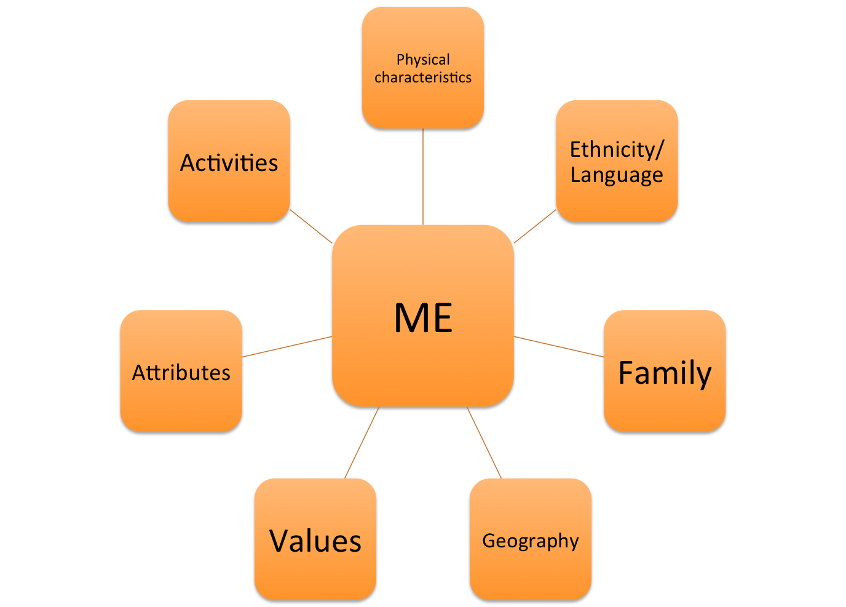
My Cultural Identity Map

Conclusion
The aim of this workbook was to assist you in supervising, mentoring or coaching your team or staff towards greater cultural responsiveness. Moving away from cultural awareness to becoming more focused on understanding our own (cultural) perspectives as starting points towards becoming more culturally responsive.
You may also want to have a look at and share with your team some of the other workbooks relating specifically to ‘Individual Practices – working with people from CALD backgrounds with disability’
Reflections
What are some of the take away messages from this workbook? Are there things you disagree with? Was there something that surprised you?

http://www.space.com/13320-big-bang-universe-10-steps-explainer.html
https://www.youtube.com/watch?v=lqt9Uyf5BVQ

