futures UPFRONT

Workbook 1.4
Person Centred Practice Across Cultures

Reflective Practice -

why different points of view matter

July 2016

This workbook has been developed for National Disability Services by:
Barbel Winter, Managing Director, futures Upfront
and Maria Katrivesis, Consultant and Trainer

First published (July 2016)
© futures Upfront

For more information and for permission to reproduce please contact:
futures Upfront
email: info@futuresupfront.com.au
web: www.futuresupfront.com.au

Produced by
NDS NSW
Level 18, 1 Castlereagh St
Sydney, NSW 2000

Funded by
NSW Department of Family and Community Services.
© This publication is copyright

All rights reserved. Except as provided in the Copyright Act 1968 (Commonwealth), no use of this work, which is within the exclusive right of the copyright owners, may be made.

Contact
NDS
02 9256 3100
ndsnsw@nds.org.au
www.nds.org.au

About National Disability Services
National Disability Services is the peak body for non-government disability services. Its purpose is to promote quality service provision and life opportunities for people with disability. NDS’s Australia-wide membership includes more than 1000 non-government organisations, which support people with all forms of disability. NDS provides information and networking opportunities to its members and policy advice to state, territory and federal governments.

Table of Contents

1. Preface 2
1.1 How to use this workbook? 2
1.2 What is this workbook about? 3
1.3 Outcomes: 3
1.4 Who is this workbook for? 3
1.5 How long will this workbook take to complete? 3
2. The Workbook 4
2.1 What is reflective practice? 4
2.2 Thoughtful Action vs Reflective Practice 5
2.3 What are the benefits of reflective practice? 6
2.4 Thinking on your feet vs Reflective Practice 6
2.5 How do we do Reflective Practice? 6
2.5.1 Reflective Practice Cycle: 7
2.6 Using Reflective Practice tools to think critically about a case study 11
3. Conclusion 17

Preface
This workbook is part of a series of resources for the disability services sector designed by futures Upfront for NDS with funding provided by the NSW Department of Family and Community Services; Ageing, Disability and Home Care.
1. Individual Practices – working with people from CALD backgrounds with disability
1.1 Empathy – a practice to connect across cultures
1.2 Active listening – unconditional positive regard across cultures
1.3 Choice making – cross-cultural differences and what can we learn from them
1.4 Reflective Practice – why different points of view matter
1.5 Working effectively with interpreters
2. Organisational Practices – building a culturally responsive organisation
2.1 Terminology and data – a guide to understanding cultural diversity and disability
2.2 Making the business case – why diversity is good for business
2.3 A culturally responsive person centred organisation – key elements
2.4 Leading towards cultural responsiveness – a practical guide for managers, team leaders and coaches
2.5 Building a diverse workforce – practical strategies
2.6 Valuing bilingual workers – strategies to recruit, train and retain
3. Community Engagement – working alongside diverse communities
3.1 1 Community @ a time – culturally responsive community engagement principles and elements
3.2 Making Links – networking with CALD Communities
3.3 Cross-cultural story-based marketing – 1 story @a time
This workbook is part of “Individual Practices – working with people from CALD backgrounds with disability” series.

How to use this workbook?
This workbook can be used in many different ways, including:
As a self-paced learning program by an individual
As a self-paced learning program for a group
As part of formal training organised by an organisation
As part of coaching and mentoring.
This workbook includes exercises and opportunities for reflections (when working by yourself) or discussions (when working with others).
There is plenty of room in your workbook to take notes and make comments.

What is this workbook about?
This workbook is about developing your person centred practice across cultures. It describes how you can use reflective practice and critical thinking to better understand how your world view impacts on and influences your behaviour and work practice.
It provides you with the tools to challenge your thinking and develop practices that help you see the world from the point of view of the people you support and your co-workers.

Outcomes:
On completion of the workbook you will:
Be able to use critical thinking to reflect on an area of your work practice
Better understand how your values and judgements impact on your work practice
Have tools to reflect on your work practice and discover your blind spots.

Who is this workbook for?
This workbook is for anyone who would like continue challenge themselves and their teams to build their skills for working culturally responsively and respectfully with people from CALD backgrounds with disability.

How long will this workbook take to complete?
This workbook should take you 60 minutes to complete. However we recommend setting aside 2 - 3 hours when using this workbook with your teams to explore and challenge your work practice.

The Workbook

What is reflective practice?
Reflective practice is “a set of abilities and skills, to indicate the taking of a critical stance, an orientation to problem solving or state of mind” (Moon, 1999: 63).
It is the process of reflecting on our experience to improve our actions and professional practice. It involves looking at how and why we think and behave in any given situation. It’s about being conscious and aware of our actions and their consequences. It forces us to question what it is that we know and how we have come to know it.
A wide range of activities associated with thinking and learning about our work practices such as:
self and peer assessment,
problem-based learning,
personal development planning, and
group work
can all be used to support a reflective practice approach.
Reflective practice encourages you to develop self-awareness and critically think about how our cultural frameworks, values and beliefs impact on our interactions with others. Regular reflective practice helps increase your awareness of your personal lens(es). It can support you to develop a greater level of self-awareness about the nature and impact of your work performance, which can lead to opportunities for professional growth and development.

Thoughtful Action vs Reflective Practice
Reflective practice is different to the everyday thoughtful action, or reflection on the go:
Thoughtful Action | Reflective Practice
Is instantaneous – one decides what to do next, thinking about it for only a split second | Requires one to take time out to reflect. It involves a conscious attempt to plan, describe, and reflect on the process and outcomes of the action
There is no cycle of clearly defined separate phases. It is an unpredictable sequence because one responds to events in the situation itself. | It is a clear cycle of separate moments in which one engages in completely different activities.
There is no describing moment, because one is engaged in acting. | As reflection occurs after action, one creates an observational record and describes the results of the action.
One is not aiming at an improvement to the practice. One is thinking about how best to do what one always does. | The major aim is to produce an improvement to the practice.
There is no element of inquiry and one is not deliberately setting out to learn something from experience. | One designs and uses inquiry strategies to find out more about one’s practice.
(Phillips, Bain, McNaught, Rice, & Tripp; 1999)

Reflection
Describe two ways you have used to reflect on your work practice?

What are the benefits of reflective practice?
Reflective practice is a useful tool for building individual cultural competence and person centred practice by:
Challenging and questioning our values, beliefs, cultural understandings and behaviours and how these influence our work practice
Scrutinising our assumptions and stereotypes
Building your knowledge and experience
Promoting your learning by developing your understanding of how you can better respond to diversity; and
Learning from successes and mistakes.

Thinking on your feet vs Reflective Practice
All of us, at some moment in our day or week, will need to react and make a decision very quickly. We reflect briefly on the situation and make a decision based on that momentary reflection. This is sometimes called: “thinking on our feet” or “reflection on the go”. People say that during these times they are operating on their instincts and are relying on previous experience and their skills to get them through the situation. These are very valuable skills to have. They enable us to act quickly. During these moments we are thinking about how best to do what we have always done. There is no element of inquiry and we are not deliberately setting out to learn something from this experience.
Reflective Practice is a conscious attempt to plan, describe, and reflect on a process and outcomes of an action. The major aim is to produce an improvement to work practice. To do this we need to consciously take time out to reflect. It involves a clear cycle of separate moments in which you are engaged in completely different activities. This is quite different to “thinking on your feet”, and allows you to share your thought processes with others, thereby not just benefiting your own learning but the learning of your teams and organisation as a whole.

How do we do Reflective Practice?
There are many tools and resources available to help you reflect on your work practice: what they all have in common is a process that enables you to look back or observe what happened, reflect and learn, and identify and apply a different approach next time.
This section will introduce you to two of them:
Reflective Practice Cycle
Johari Window Model
    - Reflective Practice Cycle:
One simple approach uses four discreet stages. Each stage involves asking yourself a series of critical questions in order to ‘unpack’ a situation and understand it from a range of standpoints, including your own and other people’s. It challenges you to think about your assumptions and identify any underlying issues that may have impacted on the situation. It acknowledges that it is okay to make mistakes as long as we learn from them.
The simple diagram below describes the four stages of reflective practice. These are:
- Describe
- Reflection
- Implementation
- Evaluation
Fig 1: Reflective Practice Cycle:

Figure 2 below outlines some of the key questions for each stage of the reflective practice cycle to help you unpack and reflect on the situation or event.

Fig 2: Reflective Practice Key Questions:

Like everything, it takes practice to get used to asking yourself these types of questions, especially when you have to think about your assumptions and preconceptions. It can be easier to reflect on our work practice when we can sit with others and think critically about it. The reflective practice framework described above in figures 1 and 2 is a great tool that can be used as an individual exercise or in a team environment. By developing and using reflective practice you will be able to bring forward ideas to help improve and enhance you own practice and the practice of others. Reflective practice can be a useful tool for sharing individual learning and improving overall team work-practice. In this context, reflective practice becomes a powerful tool for building individual and organisational cultural competence. For more information about cultural competence and person centred practice see Workbooks 2.3 and 2.4.
Video

Have a look at the video below:
What did you notice? What didn’t you notice? Why?
https://www.youtube.com/watch?v=Ahg6qcgoay4

Building our self-awareness is a critical skill and the first step for developing person centred practice across cultures. It can be difficult to develop self-awareness on our own. As the video above “Test your awareness” demonstrates, we don’t see our own blind spots but we can be a mirror for other people’s blind spots as they can be for ours.
The Johari Window:
The Johari Window is a simple tool for looking at and developing self-awareness and understanding between individuals within a group. Initially developed by Joseph Luft and Harry Ingham it is used in both business and organisational contexts.
The Johari Window can be used to document information; including feelings, experience, views, attitudes, skills, intentions, motivation, within or about a person, or in relation to their group.
It is a very useful tool to help you identify your blind spots or those of your team. It is most effective when used by teams that have already established trust and have confidence in each other.
This is viewed from four perspectives:
- What is known to you about yourself and also known by others (open area)?
- What is unknown by you about yourself but which others know
(blind area)?
- What you know about yourself that others do not know
(hidden area)?
- What is unknown to you about yourself and is also unknown by others (unknown area)?
Fig 3: Johari Window
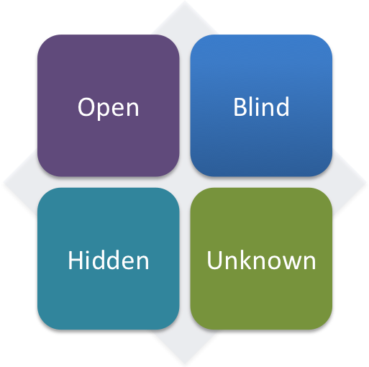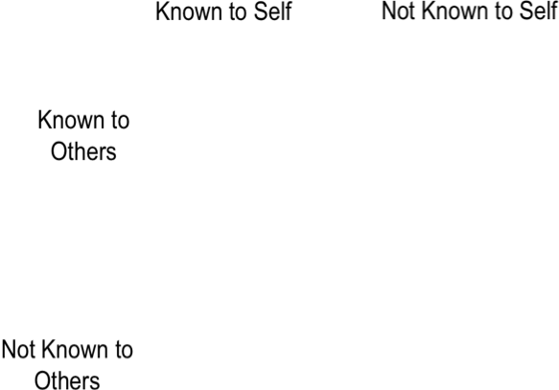
This model can be used in a reflective practice session with your team to increase self-awareness of individuals and groups to managing response to change.
Workbook Exercise
What are some of the benefits of using the Johari Model within teams?

Using Reflective Practice tools to think critically about a case study or an area of work practice
Alejandro’s story was told by a caseworker to her colleagues. The caseworker was stuck and was asking for assistance. This is how she told the story:

Case Study: What can I do differently to support Alejandro and his family?
Alejandro is a 36 year old man with moderate intellectual disability and bi-polar disorder. He lives with his parents who are in their 70s and in poor health, and his younger sister. His older sister moved out of the family home about 10 years ago.
Alejandro sometimes has sleepless nights and can be quite noisy during these periods which impacts on family members. Alejandro regularly absconds from home and wanders the suburbs. He has an obsession with travelling on trains and stays out at all hours of the night. Alejandro gets into trouble when he doesn’t pay for train tickets or coffee. He also has a history of being picked up by police.
Alejandro is not motivated to participate in meaningful activities such as a day program, supported employment or respite. He likes to be self-directed, resents being given advice, and is frustrated at not being at the same level of functioning as other people.
Alejandro’s parents were born in Peru and speak Spanish. The eldest daughter was also born in Peru, but both Alejandro and his younger sister were born in Australia. Alejandro’s mother speaks some English and his father has little English with a very strong accent making him difficult to understand. The parents seem to have difficulty understanding things and do not access any supports.
There is some conflict between Alejandro’s sisters and parents as to what is in his best interests. In the past, the parents have depended on their daughters to interpret for them but this is causing conflict as the daughters and the parents have differing understandings of Alejandro’s care needs. Obligation and pride make it difficult for the parents to openly express their inability to cope with their son, hardship of the caring role, desire for alternative accommodation, reluctance to accept assistance or actively pursue offered services.
Alejandro had been offered supported accommodation in a group home five years ago. However this was unsuccessful as Alejandro kept returning home and the parents didn’t discourage this behaviour. Alejandro’s mother is finding it very difficult to accept that her son needs to move out of the family home. However she is finding it increasingly difficult to meet his needs.

Workbook Exercise
Imagine you are the caseworker above. You have just shared the case study with your team. The following worksheet will guide you through the process. Don’t worry if there are some you can’t answer, but remember to consider all points of view not just that of the caseworker. Consider the point of view of Alejandro, his mother, sisters, etc.

Step 1. Describe (the situation)
What are the (underlying) issues that this case study highlights?
What assumptions am I making?

Step 2A. Reflect (on what happened)
From whose point of view am I seeing the situation?
(Consider: What is the point of view of….. and how do I know?)
What is the point of view of: | How do I know?
Alejandro
His mother / father
His sisters
The case worker
How do I test my assumptions?
Do I need to address any of the underlying issues? |  | How will I go about this?

Step 2B. Reflecting using the Johari Window
If you are having difficulties identifying your assumptions, the Johari Window can be used to help you identify any blind spots and consider how you might take them into account. Use the worksheet below:
 | Known to Self | Not Known to Self
Known to Others | Open | Blind
Not Known to Others | Hidden | Unknown

Reflection
Use the observations from Steps 2A (reflections) and 2B (Johari Window) to respond to this section
What skills do I have? (Consider skills you already have that enable you to work in a person centred way across culture. This section is about acknowledging the skills you already have and building from that base)

What skills do I need to develop?

Step 3. Implementation
(This section gets you to think about how you might do it differently next time. As well as considering how you might work with Alejandro and his family next time, also consider how you might develop other skills or knowledge to enable you to continue to work culturally responsively and respectfully)
What (new) strategies I will now implement?

What impact will this have on my work practice?

How will my work practice change as a result of this reflective exercise?

What impact will this have on my organisation?

Will it impact on policy, procedure, or practice?

What learning can be applied to the whole organisation?

Step 4. Evaluation
(You would only complete this section after you have gone away and applied some of the strategies identified in Step 3 above)
Has there been change?

How have I shared the learning with others?

How have I shared the learning with my organisation?

Conclusion
This workbook gives you the tools for working collaboratively with your team to develop your culturally responsive person centred practice. It explains how you can use reflective practice and critical thinking to better understand how your world view impacts on and influences your behaviour and help you see the world from the point of view of the people you support and your co-workers. Building over time your skills and the skills of your team for working culturally responsively and respectfully with people from CALD backgrounds with disability.
Reflection
What are some of the take away messages from this workbook? Are there things you disagree with? Was there something that surprised you?

